12/9/25

**TASK: create a test account in Splunk Please create APM dashboard in Splunk (download/create a sample log file - with latency, 2xx status code, and 4xx and 5xx errors and make it similar to**

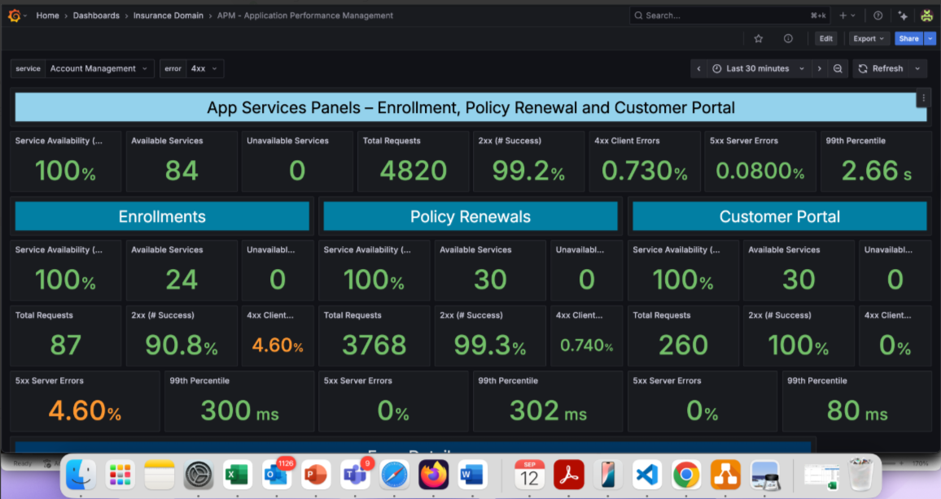

SOLUTION:

1. Create account in splunk cloud.
2. A mail received regarding a url to cloud and username ,password
   1. Url :

| [https://prd-p-i0wcm.splunkcloud.com](https://urldefense.com/v3/__https://prd-p-i0wcm.splunkcloud.com__;!!PdM5GIU!VvWnIu0CZORCnMx7ycLrShXS611jvBGtsKOG2Q8XmRW08BoZdUBQhPtvpV0nipiHJl4pNkiiaUrgJQgWzKDw9f24tCc$) |
| --- |

1. Select SEARCH AND REPORTING in the search bar. (Left side)
2. Settings -> add data ->Upload files.
3. Upload the csv file from your computer to Splunk(Ingesting the data).

**Csv data:**

_time,service,service_availability,available_services,unavailable_services,total_requests,success_pct,client_error_pct,server_error_pct,response_time_p99

2025-09-12T12:38:13Z,All,100,84,0,4820,99.2,0.73,0.08,2.66

2025-09-12T12:38:13Z,Enrollments,100,24,0,87,90.8,4.6,4.6,0.3

2025-09-12T12:38:13Z,Policy Renewals,100,30,0,3768,99.3,0.74,0,0.302

2025-09-12T12:38:13Z,Customer Portal,100,30,0,260,100,0,0,0.08

Screenshots:

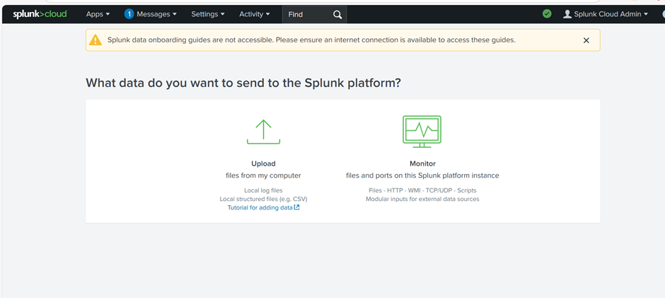

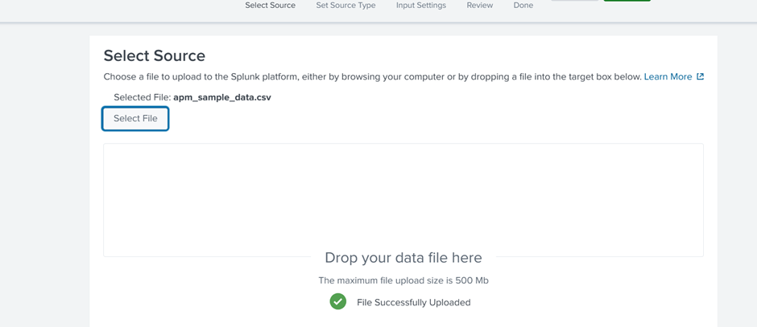

Click next:

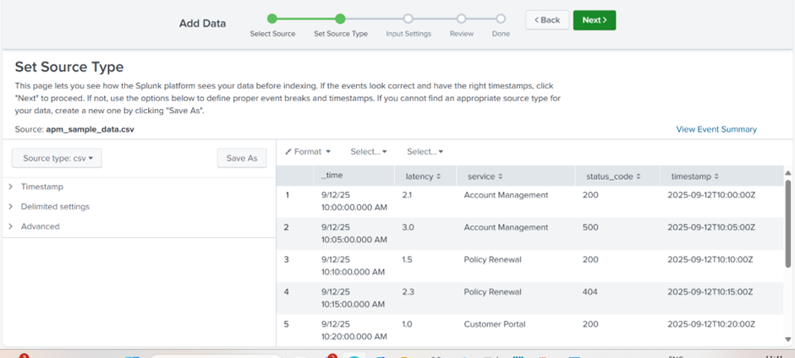



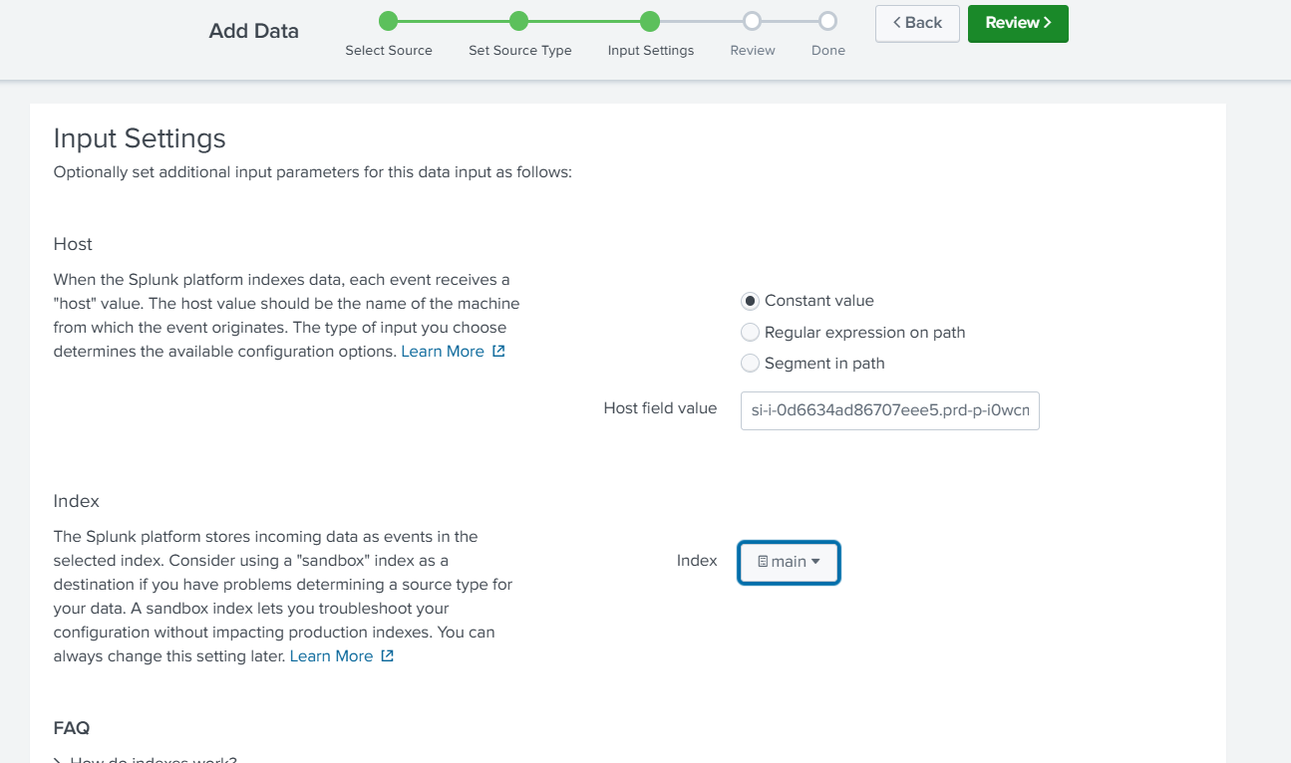

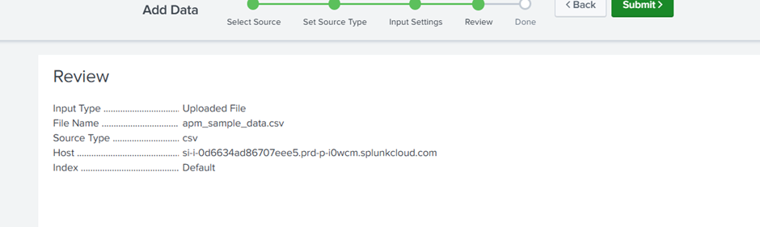

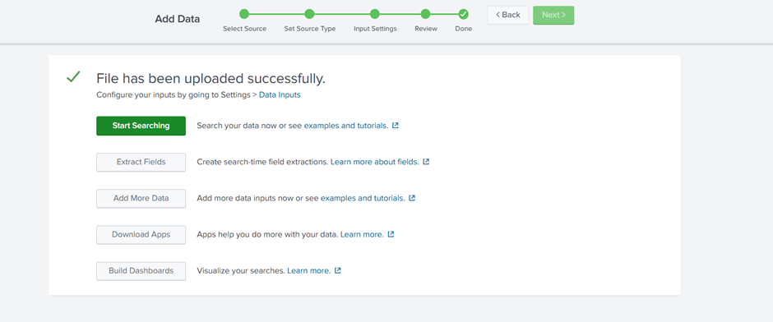

1. After uploading click on Start searching. A splunk page appears

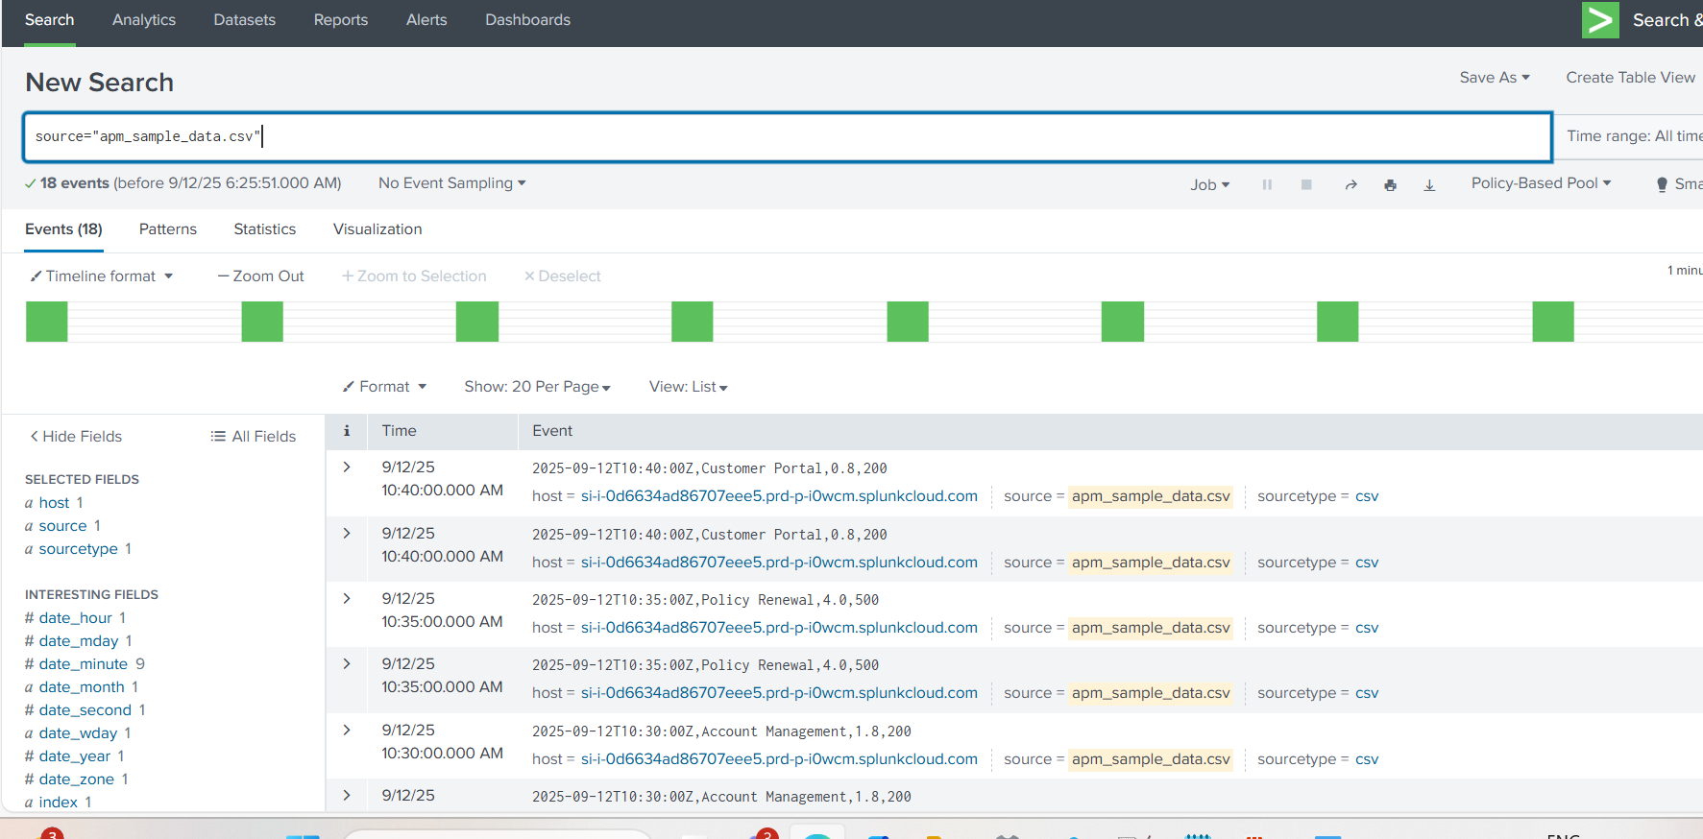

1. So in this splunk -> we should upload it and save as existing dashboard (new panels) for each query .
2. First panels:

Total req: index=main service="All" | stats values(total_requests) as total_requests

2xx: index=main service="All" | stats values(success_pct) as success_pct

4xx: index=main service="All" | stats values(client_error_pct) as client_error_pct

5xx: index=main service="All" | stats values(server_error_pct) as server_error_pct

99th percentile: index=main service="All" | stats values(response_time_p99) as response_time_p99

1. 2nd panels(Enrollment Panel)
   1. Total req: index=main service="Enrollments" | stats values(total_requests) as total_requests
   2. 2xx: index=main service="Enrollments" | stats values(success_pct) as success_pct
   3. 4xx: index=main service="Enrollments" | stats values(client_error_pct) as client_error_pct
   4. 5xx: index=main service="Enrollments" | stats values(server_error_pct) as server_error_pct
   5. 99th Percentile: index=main service="Enrollments" | stats values(response_time_p99) as response_time_p99
2. 3rd panel: Policy Renewals Panels
   1. Total req: index=main service="Policy Renewals" | stats values(total_requests) as total_requests
   2. 2xx: index=main service="Policy Renewals" | stats values(success_pct) as success_pct
   3. 4xx: index=main service="Policy Renewals" | stats values(client_error_pct) as client_error_pct
   4. 5xx: index=main service="Policy Renewals" | stats values(server_error_pct) as server_error_pct
   5. 99th percentile: index=main service="Policy Renewals" | stats values(response_time_p99) as response_time_p99
3. 4th panel: Customer Portal Panels
   1. Total req: index=main service="Customer Portal" | stats values(total_requests) as total_requests
   2. 2xx: index=main service="Customer Portal" | stats values(success_pct) as success_pct
   3. 4xx: index=main service="Customer Portal" | stats values(client_error_pct) as client_error_pct
   4. 5xx: index=main service="Customer Portal" | stats values(server_error_pct) as server_error_pct
   5. 99th percentile: index=main service="Customer Portal" | stats values(response_time_p99) as response_time_p99
4. To convert the unit

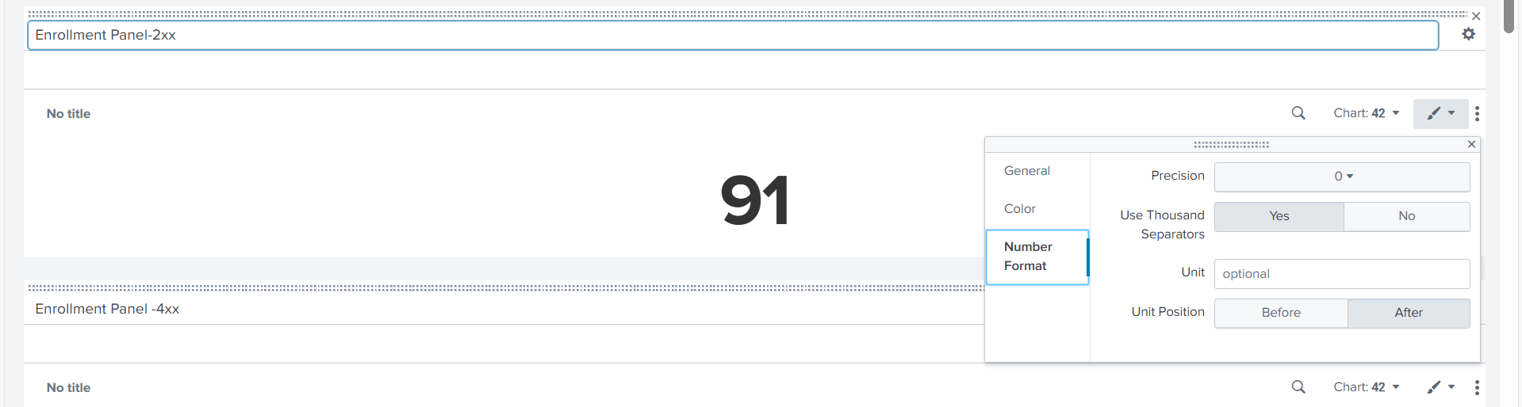

1. Drag the panels and arrange.
2. Added html code for heading EDIT->SOURCE->added html code

<row>

<html>

<h1 style="text-align: center; color: black; background-color:#94D2EC; padding: 15px; font-size: 30px;">App Services Panels - Enrollment, Policy Renewal and Customer Portal</h1>

</html>

</row>

1. For enrollments:

<row>

<html>

<h1 style="text-align: center; color: white; background-color: #007FA3; padding: 15px; font-size: 30px;"> Enrollments</h1>

</html>

</row>

1. For Policy Renewals:

<row>

<html>

<h1 style="text-align: center; color: white; background-color: #007FA3; padding: 15px; font-size: 30px;"> Policy Renewal</h1>

</html>

</row>

1. For Customer Portal:

<row>

<html>

<h1 style="text-align: center; color: white; background-color: #007FA3; padding: 15px; font-size: 30px;"> Customer Portal</h1>

</html>

</row>

1. Dashboard:

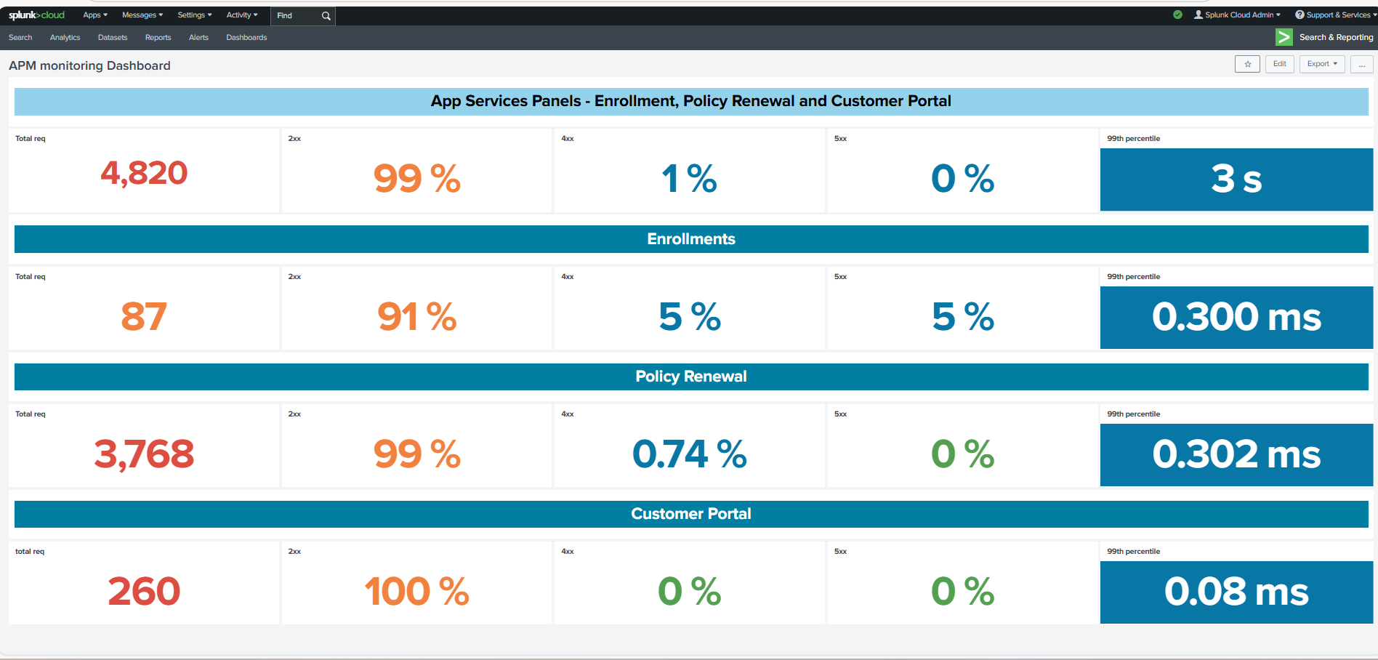

1. Backup: clone it to dashboard studio and export json

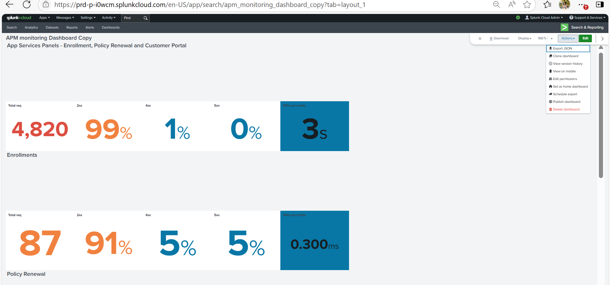

1. Github backup URL: [UST-Observability/Json_backup_files/1_splunk_dashboard1.json at main · Abhiramikannan/UST-Observability](https://github.com/Abhiramikannan/UST-Observability/blob/main/Json_backup_files/1_splunk_dashboard1.json)

Challenges faced:

* We should again upload the data if we click back of refresh.. The file is lost
* Choose the dashboard as custom not dashboard studio.(Because i lost my dashboard Once).
* Dragging the panels.
* Cant convert to decimal values(99th percentile).